

**Figure S1.** VENN diagram of shared and unique genes related to testes samples of wild (WILD) and hatchery-produced greater amberjack, dysfunctional (DysF) and non-dysfunctional (NormalF).

**Figure S2.** VENN diagram of DEGs shared and unique among DysF vs NormalF, DysF vs WILD and NormalF vs WILD comparisons. DysF, Dysfunctional Farmed; NormalF, Non-dysfunctional Farmed; WILD, wild greater amberjack.

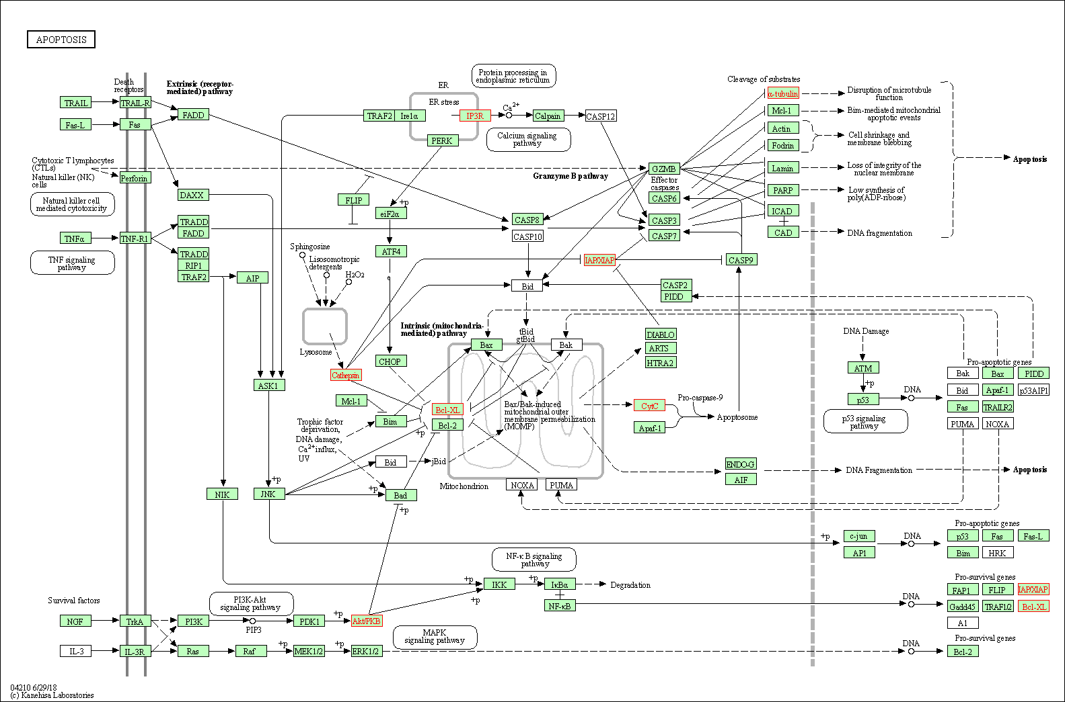

**Figure S3.** Differentially expressed genes encoding for proteins involved in apoptosis pathway (DysF vs NormalF comparison).

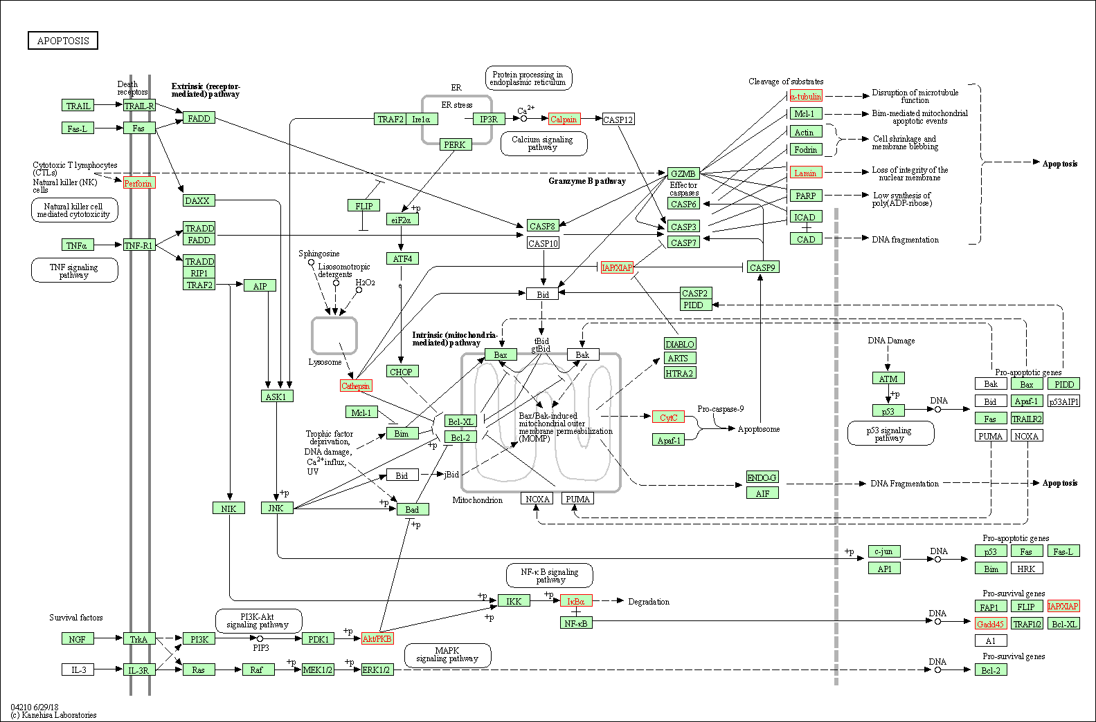

**Figure S4.** Differentially expressed genes encoding for proteins involved in apoptosis pathway (DysF vs WILD comparisons).

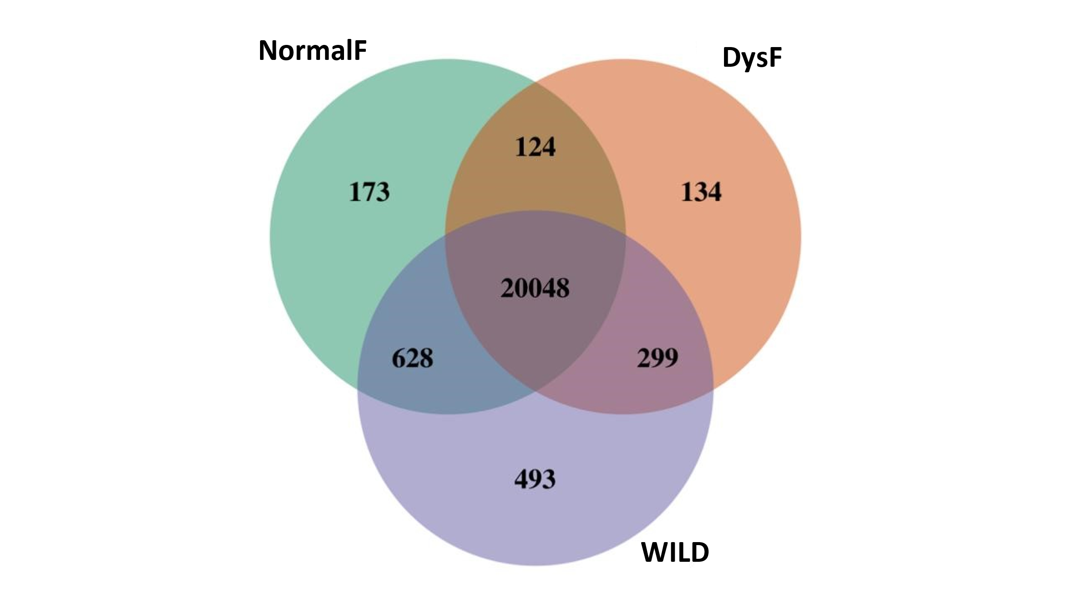

**Figure S5.** VENN diagram of shared and unique genes related to ovaries samples of wild (WILD) and hatchery-produced greater amberjack, dysfunctional (DysF) and non-dysfunctional (NormalF).

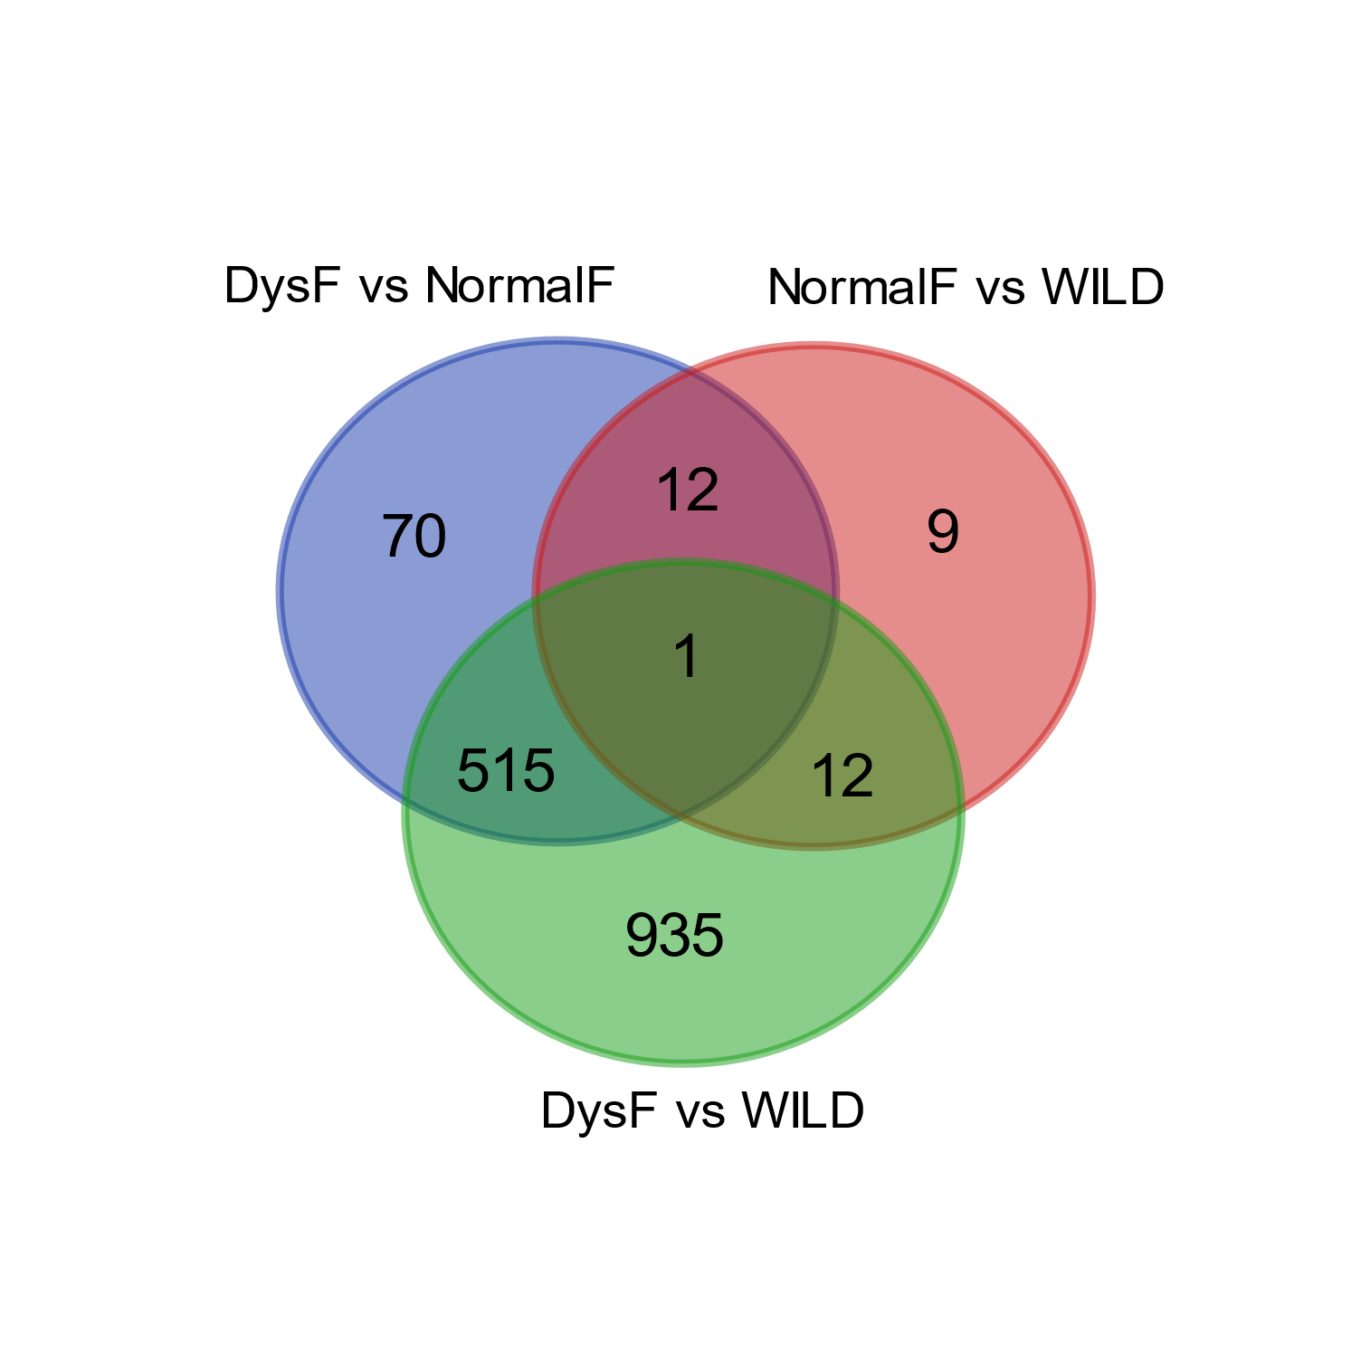

**Figure S6.** VENN diagram of DEGs shared and unique among DysF vs NormalF, DysF vs WILD and NormalF vs WILD comparisons. DysF, Dysfunctional Farmed; NormalF, Non-dysfunctional Farmed; WILD, wild greater amberjack.

**Figure S7.** Differentially expressed genes encoding for proteins involved in apoptosis pathway (DysF vs NormalF comparison).

**Figure S8.** Differentially expressed genes encoding for proteins involved in apoptosis pathway (DysF vs WILD comparisons).

**Figure S9.** Differentially expressed genes encoding for proteins involved in necroptosis pathway (DysF vs NormalF comparison).

**Figure S10.** Differentially expressed genes encoding for proteins involved in necroptosis pathway (DysF vs WILD comparison).

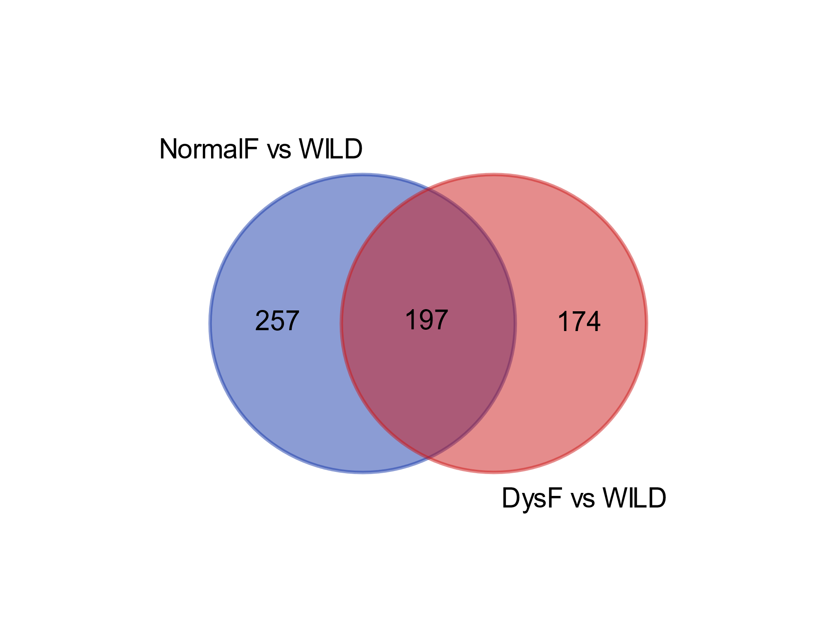

**Figure S11.** VENN diagram of DEGs shared and unique among NormalF vs WILD and DysF vs WILD comparisons. DysF, Dysfunctional Farmed; NormalF, Non-dysfunctional Farmed; WILD, wild greater amberjack.

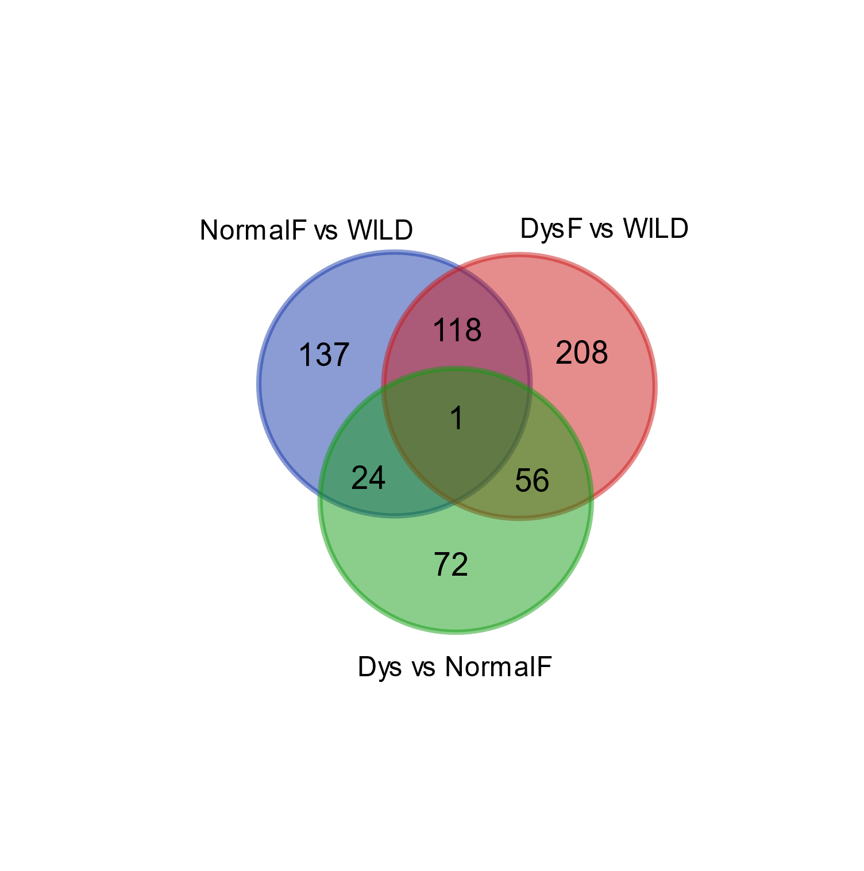

**Figure S12.** VENN diagram of DEGs shared and unique among DysF vs NormalF, DysF vs WILD and NormalF vs WILD comparisons. DysF, Dysfunctional Farmed; NormalF, Non-dysfunctional Farmed; WILD, wild greater amberjack.